**HCI –** It is the study of how people interact with computers and to what extent computers are not yet developed for successful interaction with humans.

HCI consists of 3 main parts – Users, computer and interaction

**Assignment**

**Define:**

1. User Interface Design
2. Software Design
3. User-Centered Design
4. Product Design
5. Web Design
6. User Experience Design
7. Interface System Design

**Interactive** **Design**

Most of our everyday ­­products are interactive products.

Our cell phones, smart Tv, alarm clock, watch, radio, gaming console, laptop, fitness tracker. etc.

Most of these devices are easy to use

But some other devices aren’t so easy to use. Why?

This is because some devices are designed primarily with the user in mind. They are easy to use and enjoy.

Some other devices weren’t made with the users in mind, example is a stove that requires a combination of button presses that are not obvious as to which ones to press together or separately.

These devices will need to be learned to be used.

Some devices can be frustrating to use.

Alan Cooper (in 2018), a well-known UX guru says that software still suffers from the same interaction errors that were around 20 years ago even though interaction design has been inexistence for more than 25 years. He believes that the reason for this is because many apps don’t follow even the most basic UX principles such as undo option.

To rectify these issues, we need to be able to reduce the negative aspects (the frustrations and annoyance) of the user experience while enhancing the positive ones (enjoyment and efficacy). This entails developing interactive products that are easy, efficient and pleasurable to the user’s perspective.

**Good And Poor Designs**

The concern of interactive design is to develop interactive products that are usable. By usable we mean products that are easy to learn, effective to use and provide enjoyable user experience.

A good way to think about interactive designs is to compare a well-designed and poorly designed one.

We are comparing a voice mail system used in hotel room with its well-designed alternative and the ubiquitous remote controller and a well-designed one that performs the same function.

Read the story about it

**What To Design**

You have to consider who is going to be using the interactive products, how is it going to be used and where it is going to be used. Another thing is understanding what activity people are going to do when interacting with these products.

**What is Interaction Design**

Designing interactive products to support the way people communicate and interact in their everyday and working lives.

It is about creating a user experience that augments and enhance the way people work, communicate and interact.

Components of Interaction Design

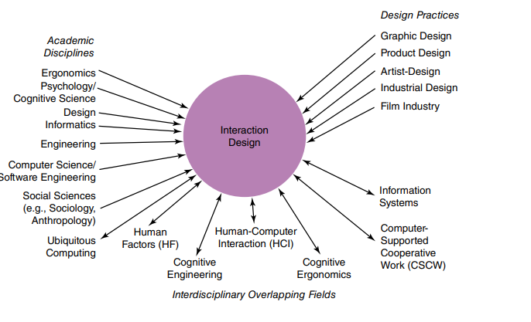

* Design Information
* Graphics Design
* Product Design
* Film Design
* Artist Design
* Industrial Design
* Information System
* Human Computer Interaction
* Computer Science/ Software Engineering
* Cognitive Engineering
* Engineering
* Human Factors

**Who Is involved in Interaction Design**

The figure above shows that many people are involved in interactive design range from Social Scientist to movie makers. This is not surprising given that technology has become a crucial aspect of our lives. Designers need to know many different things about users, technologies and the interaction among them to create effective user experiences. They also need to be able to understand how emotions work. They also need to understand the business side, technical side, manufacturing side and marketing side. It is difficult for one person to be well versed in all these diverse areas and know how to apply the different forms of knowledge to the process of interaction design.

Interaction design is ideally carried out by multidisciplinary teams where the skill sets of engineers, programmers, designers, psychologist, sociologist, marketing people, artists, production manager, toy makers, and others are drawn upon.

This is rarely the case. To have all these professionals working together.

Who to include in the team depends on a number of factors such as Size, purpose, product line, philosophy, company’s design.

**Human-computer interaction (HCI) Vs Interaction design (ID)**

HCI had a narrow focus on the design and usability of computing systems, while ID is broader and concerned with the theory, research, and practice of designing user experiences for all manner of technologies, systems, and products.

**ACTIVITY 1.1**

In practice, the makeup of a given design team depends on the kind of interactive product being built. Who do you think should be involved in developing • A public kiosk providing information about the exhibits available in a science museum? • An interactive educational website to accompany a TV series?

Comment Ideally, each team will have a number of different people with different skill sets. For example, the first interactive product would include the following individuals: • Graphic and interaction designers, museum curators, educational advisers, software engineers, software designers, and ergonomists The second project would include these types of individuals: • TV producers, graphic and interaction designers, teachers, video experts, software engineers, and software designers In addition, as both systems are being developed for use by the general public, representative users, such as school children and parents, should be involved. In practice, design teams often end up being quite large, especially if they are working on a big project to meet a fixed deadline. For example, it is common to find teams of 15 or more people working on a new product like a health app. This means that a number of people from each area of expertise are likely to be working as part of the project team.

**USER EXPERIENCE**

It refers to how a product behaves and is used by people in the real world.

It is about how people feel about a product and the pleasure and satisfaction when using it, looking at it, holding it and opening or closing it. It includes their overall impression of how good it is to use.

It is important to note that one cannot design a user’s experience but can create design features that evoke it.

**ACTIVITY 1.2**

The iPod Phenomenon Apple’s classic (and subsequent) generations of portable music players, called iPods, including the iPod Touch, Nano, and Shuffle, released during the early 2000s were a phenomenal success. Why do you think this occurred? Has there been any other product that has matched this quality of experience? With the exception of the iPod Touch, Apple stopped production of them in 2017. Playing music via a smartphone became the norm, superseding the need for a separate device. Comment Apple realized early on that successful interaction design involves creating interactive products that have a quality user experience. The sleek appearance of the iPod music player (see Figure 1.7), its simplicity of use, its elegance in style, its distinct family of rainbow colors, a novel interaction style that many people discovered was a sheer pleasure to learn and use, and the catchy naming of its product and content (iTunes, iPod), among many other design features, led to it becoming one of the greatest products of its kind and a must-have fashion item for teenagers, students, and adults alike. While there were many competing players on the market at the time—some with more powerful functionality, others that were cheaper and easier to use, or still others with bigger screens, more memory, and so forth—the quality of the overall user experience paled in comparison to that provided by the iPod. The nearest overall user experience that has all of the above is not so much for a product but for a physical store. The design of the Apple Store as a completely new customer experience for buying technology has been very successful in how it draws people in and what they do when browsing, discovering, and purchasing goods in the store. The products are laid out in a way to encourage interaction.

**Understanding Users**

The main reason for having a better understanding of users is so that it can help designers understand how to design interactive products that give good user experience or match a user’s needs.

**Accessibility and Inclusiveness**

Accessibility is the extent to which an interactive product Is accessible by as many people as possible.

The focus is on people with disabilities. Companies like google and Apple provide tools for their developers to promote this. There are apps like hearing aid compatibility, built-in screen reader and Apple’s voice over lets the user know what’s happening on its devices so they can easily navigate.

Inclusiveness: It means being fair, open and equal to everyone. It is an approach where designers strive to make their products and services accommodate the widest possible number of people.

Ex. Is making sure iPhone is designed for all and make available to everyone.

**Usability and User Experience Goals**

Part of the process of understanding users is to be clear about the primary objectives of developing an interactive product for them.

Usability goals is concerned with meeting specific usability criteria, such as efficiency.

User Experience is concerned with the explicit nature of the user’s experience.

How a product feels and looks is linked with usability of the product but it is a user experience. How the user experience comes is down to the usability of the product.

**Usability goals**

1. Efficiency - The way the product carries out its task.
2. Effectiveness - How good the product is at doing what it is supposed to.
3. Safety - Protecting the users from dangerous conditions and undesirable situations.
4. Learnability - How easy the system is to learn.
5. Memorability - How easy it is to remember how to use the system once learned.
6. Utility - The extent to which the product provides the right kind of functionality so that the user can do what they need to do.

Usability has 3 components: Efficiency, Effectiveness, Satisfaction.

**Usability Study**: Study of interaction between people, products and environment.

Example: Psychology, Behavioral Science.

**Usability Testing**: Scientific evaluation of usability parameters as per the user’s requirements, competence safety, prospects and satisfaction.

**Acceptance Testing:** A testing procedure that is performed by the users as a final checkpoint before signing off from a vendor.

**Questions to be asked to determine if the goals are being met.**

**Effectiveness**: Does the product allow people carry out their work, access information they need or buy goods they want?

**Efficiency**: Once the users have learned how to use the product, **can they sustain a high level of**

**Productivity?**

**Safety**: What is the range of errors that are possible using the product.

**What measures are there to permit users to recover easily from them.**

**Utility**: Does the product have an appropriate set of functions that will allow users to carry out tasks in the way they want to do them.

**Learnability**: Is it possible for users to know how to use the system by exploring the interface and trying certain actions.

**Memorability**: What type of interface support is provided for the users to remember how to use the system.

User Experience Goals

**Desirable Aspects Undesirable Aspects**

1. Satisfying 1. Boring
2. Enjoyable 2. Patronizing
3. Helpful 3. Frustrating
4. Fun 4. Childish
5. Challenging 5. Annoying
6. Pleasurable 6. Unpleasant
7. Entertaining 7. Making one feel stupid
8. Exciting 8. Making one feel guilty
9. Engaging 9. Gimmicky
10. Surprising 10. Cutesy
11. Proactive
12. Supports creativity
13. Motivating
14. Enhances sociability
15. Rewarding
16. Experiencing flow

**Activity 1.3**

**There are more desirable than undesirable aspects of the user experience listed above. Why do you think this is so? Should you consider all of these when designing a product?**

The two lists we have come up with are not meant to be exhaustive. There are likely to be more—both desirable and undesirable—as new products surface. The reason for there being more of the former is that a primary goal of interaction design is to create positive experiences. There are many ways of achieving this. Not all usability and user experience goals will be relevant to the design and evaluation of an interactive product being developed. Some combinations will also be incompatible. For example, it may not be possible or desirable to design a process control system that is both safe and fun. Recognizing and understanding the nature of the relationship between usability and user experience goals is central to interaction design. It enables designers to become aware of the consequences of pursuing different combinations when designing products and highlighting potential trade-offs and conflicts. As suggested by Jack Carroll (2004), articulating the interactions of the various components of the user’s experience can lead to a deeper and more significant interpretation of the role of each component

**Design Principles –** It is used by designers to aid their thinking when designing for user experience

The best know design principles are:

1. Visibility
2. Feedback
3. Affordance
4. Constraints
5. Consistency

**Visibility:** The features should be well designed and visible. Like in the remote control earlier, the buttons should be visible enough. The more visible functions there are, the more likely your user will be able to know what to do next.

**Feedback**: It involves sending back information about what action has been done and what has been accomplished, allowing the person to continue with their activity. Feedback can be audio, tactile, verbal, visual and combination of these.

**Constraint**: It refers to determining ways of restricting the kind of user interaction that can take place at a given moment. There are many common ways but one common way is to deactivate certain menu options by shading them grey, thereby restricting the user only to actions permissible at that stage.

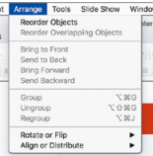

**Consistency**: This refers to designing similar interfaces to have similar operations and ways for achieving similar tasks.

**Affordance**: It is an attribute of an object that allows people to know how to use it. It means to give a clue

Ex. A mouse gives people a clue that it should be clicked and dragged, by the way of its shape and buttons.

A door’s handle. **Making interaction obvious and easy to know how to interact with it.**

There are two types of affordance:

1. Real affordance: Applies to physical objects like the door knob. (Clicking a mouse)
2. Perceived affordance: Applies to objects on a screen. (Swiping a screen).

**ACTIVITY 1.4**

One of the main design principles for website design is simplicity. Jakob Nielsen (1999) proposed that designers go through all of their design elements and remove them one by one. If a design works just as well without an element, then remove it. Do you think this is a good design principle? If you have your own website, try doing this and seeing what happens. At what point does the interaction break down?

Comment Simplicity is certainly an important design principle. Many designers try to cram too much into a screenful of space, making it unwieldy for people to find the element in which they are interested. Removing design elements to see what can be discarded without affecting the overall function of the website can be a salutary lesson. Unnecessary icons, buttons, boxes, lines, graphics, shading, and text can be stripped, leaving a cleaner, crisper, and easier-to-navigate website. However, graphics, shading, coloring, and formatting can make a site aesthetically pleasing and enjoyable to use. Plain vanilla sites consisting solely of lists of text and a few links may not be as appealing and may put certain visitors off, never to return. Good interaction design involves getting the right balance between aesthetic appeal and the optimal amount and kind of information per page.

**Phases of Interaction Design**

1. **Discover**: Designers gather insight into the problem
2. **Define**: Designers briefly frame the design challenge || The area to focus upon.
3. **Develop**: Solutions or concepts are created, prototyped, tested, and iterated.
4. **Deliver**: The resulting project is finalized, produced, and launched.

**ACTIVITY** **2.1**

This activity asks you to apply the double diamond of design to produce an innovative interactive product for your own use. By focusing on a product for yourself, the activity deliberately de-emphasizes issues concerned with involving other users, and instead it emphasizes the overall process. Imagine that you want to design a product that helps you organize a trip. This might be for a business or vacation trip, to visit relatives halfway around the world, or for a bike ride on the weekend—whatever kind of trip you like. In addition to planning the route or booking tickets, the product may help to check visa requirements, arrange guided tours, investigate the facilities at a location, and so on.

1. Using the first three phases of the double diamond of design, produce an initial design using a sketch or two, showing its main functionality and its general look and feel. This activity omits the fourth phase, as you are not expected to deliver a working solution.

2. Now reflect on how your activities fell into these phases. What did you do first? What was your instinct to do first? Did you have any particular artifacts or experiences upon which to base your design?

Comment

1. The first phase focuses on discovering insights about the problem, but is there a problem? If so, what is it? Although most of us manage to book trips and travel to destinations with the right visas and in comfort, upon reflection the process and the outcome can be improved. For example, dietary requirements are not always fulfilled, and the accommodation is not always in the best location. There is a lot of information available to support organizing travel, and there are many agents, websites, travel books, and tourist boards that can help. The problem is that it can be overwhelming. The second phase is about defining the area on which to focus. There are many reasons for travelling—both individual and family—but in my experience organizing business trips to meetings worldwide is stressful, and minimizing the complexity involved in these would be worthwhile. The experience would be improved if the product offers advice from the many possible sources of information and tailors that advice to individual preferences. The third phase focuses on developing solutions, which in this case is a sketch of the design itself. Figure 2.2 shows an initial design. This has two versions of the product—one as an app to run on a mobile device and one to run on a larger screen. The assumptions underlying the choice to build two versions are based on my experience; I would normally plan the details of the trip at my desk, while requiring updates and local information while traveling. The mobile app has a simple interaction style that is easy to use on the go, while the larger-screen version is more sophisticated and shows a lot of information and the various choices available.

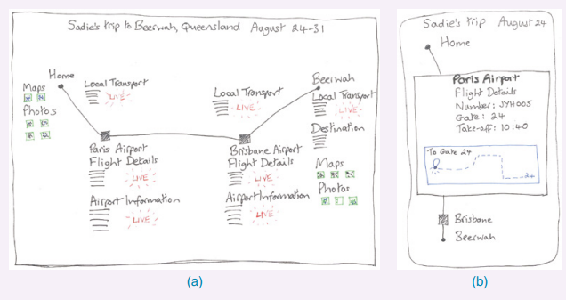

2. Initially, it wasn’t clear that there was a problem to address, but on reflection the complexity of the available information and the benefit of tailoring choices became clearer. The second phase guided me toward thinking about the area on which to focus. Worldwide business trips are the most difficult, and reducing the complexity of information sources through customization would definitely help. It would be good if the product learned about my preferences, for example, recommending flights from my favorite airline and finding places to have a vegan meal. Developing solutions (the third phase) led me to consider how to interact with the product—seeing detail on a large screen would be useful, but a summary that can be shown on a mobile device is also needed. The type of support also depends on where the meeting is being held. Planning a trip abroad requires both a high-level view to check visas, vaccinations, and travel advice, as well as a detailed view about the proximity of accommodation to the meeting venue and specific flight times. Planning a local trip is much less complicated. The exact steps taken to create a product will vary from designer to designer, from product to product, and from organization to organization (see Box 2.1). Capturing concrete ideas, through sketches or written descriptions, helps to focus the mind on what is being designed, the context of the design, and what user experience is to be expected. The sketches can capture only some elements of the design, however, and other formats are needed to capture everything intended. Throughout this activity, you have been making choices between alternatives, exploring requirements in detail, and refining your ideas about what the product will do.

**User-Centered Approach/Design**

It is also called User Driven Design

**The process of collecting feedback from users to improve the design.**

It is a process in which the user needs are given extensive attention at each stage of design process.

**The goal is to have products with high usability.**

This is a design process driven by research, data analysis, and test result rather than aesthetics.

**The principles of HCI are**:

1. Early focus on users and tasks - This requires observing users doing their normal tasks, studying the nature of those tasks, and then involving users in the design process.
2. Empirical measurement - users interact with simulations and prototypes, and their performance and reactions are observed, recorded, and analyzed.
3. Iterative design - When problems are found in user testing, they are fixed, and then more tests and observations are carried out to see the effects of the fixes.

**Basic Activities of Interaction Design**

1. Discover the requirements for the interactive products.
2. Designing alternatives that meet those requirements.
3. Prototyping the alternative designs so that they can be communicated and assessed.
4. Evaluating the product and the user experience it offers throughout the process.

**Drawbacks of User-Centered Design**

1. Passive User Involvement.
2. Designers may ask incorrect questions to users.
3. User’s perception of the new interface might be inappropriate.

**LIFE CYCLE MODEL OF INTERACTION DESIGN**

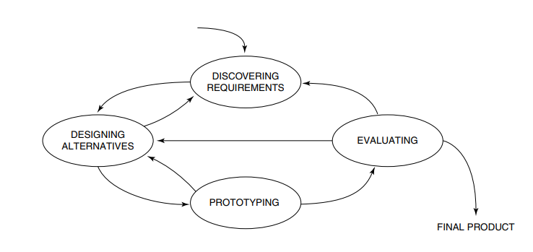

**Issues of user-centered design**

1. Who are the users?
2. What are the users’ needs
3. How do we generate alternative designs
4. How to choose among the alternatives.
5. How to integrate interaction design with other lifecycle models.

**Conceptualization Interaction**

 Conceptualizing means to understand something.

It is important to conceptualize new ideas in a design project. This is called ***proof of concept***. This helps to answer:

* How realistic is it to develop
* How desirable and useful will it be
* What problem would this address?
* Can this be solved in another way

For example; a project to create a robot waiter

* How intelligent does it have to be
* How would it need to move to appear to be talking
* What would the customers think of it
* Would they think it is too gimmicky and get easily tired of it? Or, would it always be a pleasure for them to engage with the robot, not knowing what it would say on each new visit?
* Could it be designed to be a grumpy extrovert or a funny waiter
* What might be the limitations of this voice-assisted approach?

The design team may assume users have a problem and try to propose a solution, they should consider these questions:

* Are there problems with an existing product or user experience? If so, what are they?
* Why do you think there are problems?
* What evidence do you have to support the existence of these problems?
* How do you think your proposed design ideas might overcome these problems?

The benefits of conceptualizing the design space in this way are as follows:

* Orientation: Enable the design team to ask specific kinds of questions about how the conceptual model will be understood by the targeted users.
* Open-Mindedness:  Allowing the team to explore a range of different ideas to address the problems
* Common Ground: Allowing the design team to understand and agree upon a set of common terms, reduces the chance of misunderstandings and confusion arising later.